Referral Form
Learning Disability Service - Single Point of Access

Please complete form as best you can; If you would like help or support completing the form, contact 0300 456 0111 (ask for the Learning Disability Health Team) or email whc.ctpldreferrals@nhs.net

Please note we do not provide emergency/urgent services

NHS 111 can help if you have an urgent medical problem and you’re not sure what to do.

Today’s Date:

Name: | [Full Name]
Address:
Telephone Number
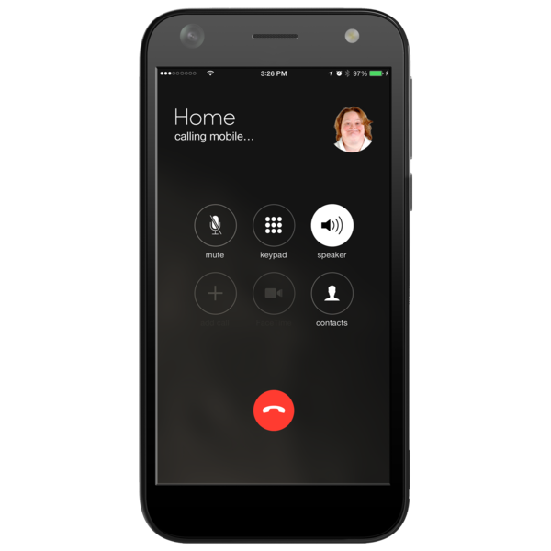
Email @
Date of Birth: | [Date of Birth]
NHS No. | [NHS Number]
Your GP Address:
Your GP Telephone Number:

How can we help you?

The best time for us to contact you is | Please tick the days that are best for you
 | Monday
 | Tuesday
 | Wednesday
 | Thursday
 | Friday
The best time for us to come and see you is | Please tick the time that is best for you
 | Morning
 | Afternoon
 | The best person to talk to about me is:

Wiltshire Learning Disability Team
Postal Address  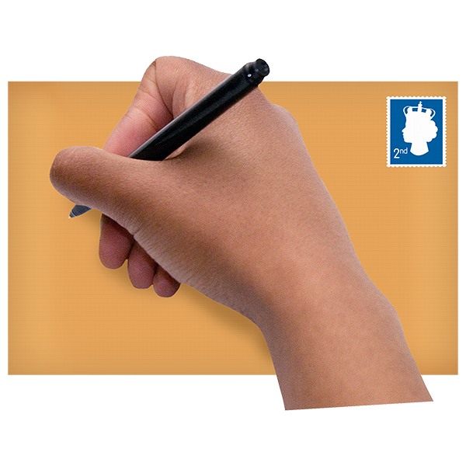 | Savernake Hospital  London Road  Marlborough  Wiltshire  SN8 3HL
Telephone number | 0300 456 0111
Opening Hours | Monday- Friday 9.00am-5.00pm
Email | whc.ctpldreferrals@nhs.net

