Osteoarthritis in your Hip or Knee?

Please follow this link to read Wiltshire Health and Cares Osteoarthritis patient information leaflet:
Managing-hip-or-knee-osteoarthritis.docx (live.com)

Try the Online ESCAPE pain course….

If you would like additional help trying to improve/manage your knee/hip pain, try using the ESCAPE-pain digital tools and follow the programme twice a week (further information below).

ESCAPE pain digital tools

ESCAPE-pain Online, and the ESCAPE-pain app both replicate the face-to-face programme you would normally be offered and are free to use.

ESCAPE-pain Online is the web-based version of the ESCAPE-pain app. It can be accessed https://escape-pain.org/ESCAPE-pain-Online and viewed on a computer or mobile device. No need to have a smart phone.
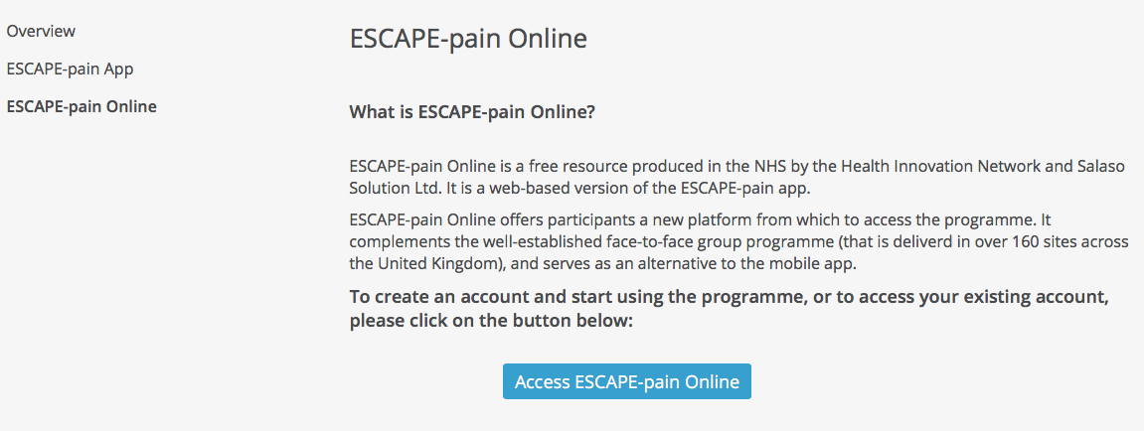

- ESCAPE-pain app is available on Android smartphones and tablets.
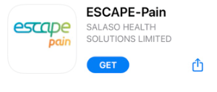
Both tools take you through a six-week programme, with two sessions per week, each containing:
- Exercise videos with simple, easy to follow exercise with clear instructions that were developed so people could do the exercises safely in their homes;
- Educational videos with engaging animations giving simple advice and information to help people understand how to better manage their condition;
- Individual progress chart to track their improvement over time.​

Try these top tips for getting the best out of the ESCAPE-pain support tools available via the ESCAPE pain homepage:
https://escape-pain.org/ESCAPE-pain-Online
