This information leaflet has been designed with you in mind. It can be used as both a resource pack and a record of the investigations, treatments and other options you have tried for managing your joint pain.

Page | Content
2-3 | My history and management plan
4 | What is Osteoarthritis?
5 | Benefits of regular exercise
6 | Managing your weight
7 | Activity pacing and setting goals
8 | Managing pain and reducing joint stress
9 | Managing flare ups
9-10 | Surgery
11-12 | Simple home exercises
13 | Further information

Name: …………………………………………………………...
NHS number: ………………………………………………………..
GP: ………………………………………………………………………
Which joints cause me pain? …………………………………………………………………….
My X-Ray/Scan results (last 5 years) (See page 4 for more information)
Investigation | Joint  (left/right) | Date  (DD/MM/YY) | Result | Verified by  (GP Signature)

My knee function – Quick test
Number of times you can go from sitting to standing in 1 minute – this is a good functional test to assess improvements. Ensure you are able to do this safely before attempting a timed test.

Date
Number of sit to stand

My Weight Target
My Ideal Weight range (BMI 18.5-24.9): ……………………………………….
Date
Weight
BMI

What have I tried to help my symptoms?

Things to try | What I did | Date | What was the outcome?
Aerobic Activity e.g. cycling, swimming, walking, fitness classes
Physiotherapy

OA Knee/hip class

Escape Pain class

Escape Pain app/online

Weight management group
Independent weight loss
Footwear – supportive shoes, insoles
Walking aids: Walking stick, wheeled
walkers etc.
Creams and ointments: e.g. anti-inflammatory gel.

Pain relieving medicine e.g. paracetamol, ibuprofen, co-codamol
Heat and ice

Pacing activities

TENS

Peer support group/family/ friends
Relaxation

Other;

What is osteoarthritis (OA)?

Osteoarthritis (OA) is the most common form of joint arthritis. The knee is most commonly affected but it can also affect other joints including the hip. When a joint starts to develop OA the cartilage covering the joint gradually becomes roughened and worn. All of the surrounding tissues become more active as they try to repair the damaged cartilage. As a result bony growths may appear and the capsule and ligaments surrounding the joint becomes thicker to help keep the joint stable. Extra synovial (joint lubricating) fluid is produced.
Common symptoms include pain, swelling, stiffness and grating/grinding on movement. The pain may be worse after certain activities or periods of rest and may vary from day to day. For some symptoms may be mild and intermittent. For others symptoms can be more severe and affect function.

Many millions of people in the UK live with OA. Symptoms may present over a long period of time. They don’t necessarily get worse and by following the right advice you can improve your symptoms and lead a healthy, active life. X-ray changes are not a good indicator of pain or disability. On many occasions a diagnosis can be made based on age and history without the need for an x-ray or other investigations.
OA is more common in older persons (over 45 years) but can affect younger people too. Obesity is a major factor due to increased stress through the joints. Previous injury (e.g. fractures) or other joint disease (e.g. rheumatoid arthritis) can contribute. Genetic factors can play a part although the reason for this is unclear. Normal exercise and activity doesn’t cause OA although activities and occupations that put repeated, heavy stresses through the joint may contribute.

NICE guidelines for OA

The National Institute for Health and Care Excellence produced guidelines for managing OA in 2008 (NICE CG177). These were updated in 2014. They recommend the following:
  - Weight management
  - Reduce joint stress
  - Pain relief
  - Regular exercise
  - Activity pacing

Benefits of regular exercise

There are 4 main types of exercises and using a combination of these will help to reduce your pain in most cases.
  - Strengthening – to build the muscles and improve support to the joint
  - Stretching – to maintain muscle length
  - Range of movement– to relieve stiffness and maintain flexibility of the joint
  - Cardiovascular – to maintain/improve fitness e.g. exercise bike, walking

Government guidelines state that we should be doing at least 150 minutes of moderate activity per week. This should include 30 minutes of cardiovascular exercises most days and 2 sessions of strength and balance exercises each week. Try the exercises found on page 11-12 of this leaflet. Although the exercises may feel hard to do at first they should not greatly aggravate your pain.

Continuing exercise long term is the best thing you can do to ensure you stay fit, strong and minimise your pain. Research has shown that increasing activity/exercise reduces pain in the long term. There are also good psychological and social benefits of exercise. There are many exercise options and it is important to pick one that feels right for you and is enjoyable.

There are many options available for continuing exercise and activity in your area including walking groups and local exercise classes. One useful website for finding local activities is: https://www.activewiltshire.org.uk/ . Your physiotherapist or GP can complete an Active Health referral so you can access your local leisure centre at a subsidised rate.

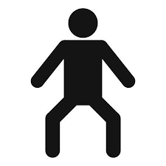
Managing your weight
Being overweight will increase the stress on your joints and can make your pain worse over time. Body mass index (BMI) is the common way to calculate if you are a healthy weight. This online tool can quickly calculate your BMI: https://www.nhs.uk/live-well/healthy-weight/bmi-calculator/

BMI results indicate;
- < 18.5 underweight
- 18.5-24.9 ideal weight
- 25-30 overweight
- >30 obese

If your BMI is high, speak to your GP/physiotherapist about a weight loss programme suitable for you. The following website has information what is available in your local area: http://www.wiltshire.gov.uk/public-health-weight

Healthy balanced diet

Eating a healthy balanced diet will help to keep your weight within the normal limits. It will also help to provide your body with the nutrients it needs for good bone and joint health. General guidelines are;
- Base meals on starchy foods such as potatoes, bread, rice and pasta, choosing wholegrain where possible.
- Eat plenty of fibre-rich foods – such as oats, beans, peas, lentils, grains, seeds, fruit and vegetables, as well as wholegrain bread, brown rice and pasta.
- Eat at least five portions of fruit and vegetables a day in place of foods higher in fat and calories.
- Avoid eating too much processed food, sugary drinks and foods high in unhealthy fats
- Eat a healthy and filling breakfast.
- Watch the portion size of meals and snacks, and how often you are eating.
- Avoid taking in too many calories in the form of alcohol.
- See the useful websites at the back of this leaflet for more information

ACTIVITY PACING

Prolonged or intensive periods of activity can make the pain worse, which in turn leads to long periods of rest. This can then lead to loss of muscle power and stiffness in the joint. Pacing activities can help to avoid this unhelpful cycle. The following ideas may help;
- Make a plan and prioritise what has to be done on a daily basis (a pain diary may help initially)
- Start activities with realistic low baselines, then build up gradually
- Take regular rests between activities but avoid prolonged periods of rest
- Change position frequently whilst performing activities
- Do a small amount often rather than doing everything at once

SETTING GOALS

Setting goals can be a useful way of getting started and tracking your progress. A goal should be SMART;

S – Specific – Think about something specific you want to achieve
M – Measurable – You need to know when you’ve achieved the goal
A – Achievable – Aim for something that isn’t too ambitious
R – Relevant – Is this a suitable goal for you?
T – Timed – When are you hoping to achieve your goal?

What is my goal?

--------------------------------------------------------------------------------------------------------------------------------------------------------------------------------------------------------------------------------------------------------------------------------------------------------------------------------------------------------------------------------------------------------------------------------------------------------------------------------------------------------------------------------------------------------------------------------
MANAGING PAIN

Pain can vary in OA from a dull ache to sharp or burning pain. Many factors can influence pain including anxiety, stress, fear, previous health experiences and beliefs. There are many things you can do to help manage your pain.

Pain relieving medicines
- Talk to your GP if you feel you need some medication to help your pain.
- Paracetamol is the most commonly used medication. Take as directed and never take more than the dose advised by your GP.
- Topical non-steroidal anti-inflammatories (NSAIDs) may be prescribed for knee OA usually in the form of a gel.
- Less commonly you may be prescribed NSAIDs e.g. ibuprofen or naproxen
- For more severe pain occasionally you may be prescribed stronger pain killers e.g. or opioids such as tramadol
- In some cases a steroid injection into the joint may help for the relief of pain.

Other ways to ease pain
- Exercise – Regular gentle exercise can help to ease pain
- Heat – Try using gentle heat such as a wheat bag for 10 minutes
- Cold – Try crushed ice or a bag of frozen peas wrapped in a towel for 10 minutes. Don’t apply ice directly to the skin as there is the risk of a burn
- Walking aids –such as a stick or walking poles to give support when walking
- Relaxation – This can be especially useful if you are feeling stressed or having difficulties sleeping. The resources at the back of the booklet include some relaxation resources.
- Aids to daily living - Make daily activities easier and reduce stress on joints e.g. chair/bed raises, sock aid, toilet seat raise or helping hand.

Other ways to reduce joint stress
- Try shock absorbing footwear/insoles
- Walking aids can reduce the weight going through your joints
- Low impact exercises e.g. exercise in water, cycling/static bike, cross trainer, Pilates, Tai Chi
- Try other aids e.g. kneeling pads
- Knee braces or supports can be useful in some cases to help the joint feel more stable or reduce pain. It is important you seek advice to find the most appropriate one for you. You shouldn’t wear it all the time and remember you also need to be doing exercises to maintain the strength in your knee.

Managing flare ups

Most people with OA of the knee and hip can manage their symptoms effectively and live a normal active life. It can take a few months to notice changes in pain so do persevere. Most people with OA will get flare ups occasionally. A flare up is a temporary increase in symptoms. These can be caused by over or underactivity, illness or fatigue. Often there is no clear reason for a flare up and it will usually settle within a few days.
To manage a flare up;
  - Use ice or heat to help with pain relief.
  - Continue gentle exercises and walking
  - If suitable increase your pain relieving medications for a few days
  - Try some relaxation techniques
  - Gradually get back to your normal levels of activity

Surgery

Very few people with OA will require surgery. Referral for surgery is normally considered only if all core treatments (i.e. pain control, physiotherapy and OA exercise class) have been tried and your quality of life is adversely affected. It is important to try exercise and lifestyle measures before considering surgery.

The most commonly used surgery is total joint replacement - This replaces the damaged joint surfaces with a replacement joint, which is usually a combination of metal and plastic.

Total knee replacement Total hip replacement
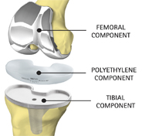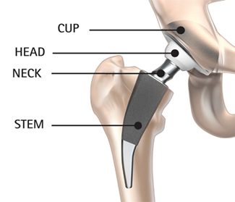
Other (less common) types of surgery for OA:
- Osteotomy – to realign the bones
- Partial knee replacement (unicompartmental)

Benefits of joint replacement surgery include;
Improved movement of the joint, pain relief, improved joint alignment and stability. This should lead to improved function and a better quality of life.

Risks of joint replacement
A blood clot in the calf (DVT) gives symptoms of calf pain, heat and swelling. If this happens you should seek urgent medical advice. Some patients are given a course of anticoagulant injections following surgery to help to prevent this.
Other risks include infection, stiffness, loosening/failure, dislocation, leg length discrepancy, need for blood transfusion, damage to ligaments, nerve or blood vessels, fracture of the bone around the joint and death.

Recovery following joint replacement surgery
You will usually stay in hospital for between 1-3 days following surgery. You will see the physiotherapist as soon as possible after the operation to begin exercises and walking. You will go home once your wound has been checked and the physiotherapists are happy with your movement and walking. You will usually have a walking aid such as crutches for the first few weeks. It will take at least 6 weeks to recover from the operation, often longer. Of course each patient is different and each will have a different experience. Your leg may be swollen and this can take at least 3 months to settle completely. There will be restrictions on driving and advice will be given on when you can return to work. You would normally have a follow up with a member of the Orthopaedic team around six weeks after your operation.
Recovery from knee replacement
You will need to work hard with exercises to regain the movement and muscle strength. This may be uncomfortable at first but it is vital to get the knee moving. Often you will be referred for further outpatient physiotherapy when you go home. Clicking is common due to the hard implant surfaces contacting each other. You will have a small area of numbness on the outer side of your knee.

Recovery from hip replacement
You will have exercises to do at home, but you do not usually need outpatient physiotherapy. You will need to be careful with certain movements such as twisting or bending too far and will need to avoid sleeping on your side for a few weeks.

SIMPLE HOME Exercises for oa
These exercises will help to reduce pain and increase function in your knee. You may only be able to do a few repetitions at the start, but this will improve over time. A small increase in pain while exercising is okay as long as it goes away within 30 minutes and is not worse the next day. If this happens, don’t worry, do fewer repetitions the next time and then gradually build up again. Start with one exercise and add more in as you feel able. Try to do the exercises 4-5 times per week.

- Static quadriceps
Sitting with your leg straight, push the back of your knee into the bed/floor, hold for 5 seconds, then release. Repeat 10 times

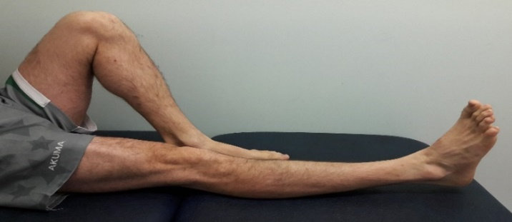

- Inner range quadriceps (Knee wedge)
Sitting with your knee over a rolled up towel, push the back of your knee into the towel and lift your foot off the bed/floor, hold for 5 seconds, then return your foot to the surface. Repeat 10 times.

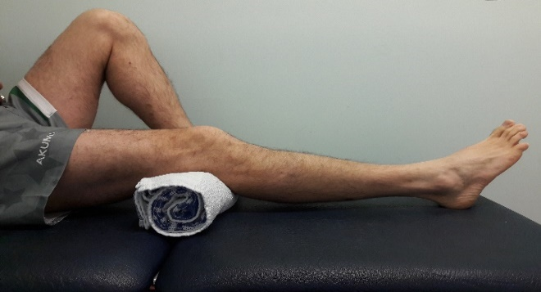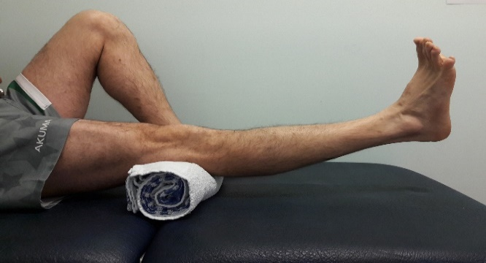

- Straight leg lifts
Lying or sitting with one leg bent and the other one straight. Lift your straight leg up, hold for 5 seconds, then release. Repeat 10 times.

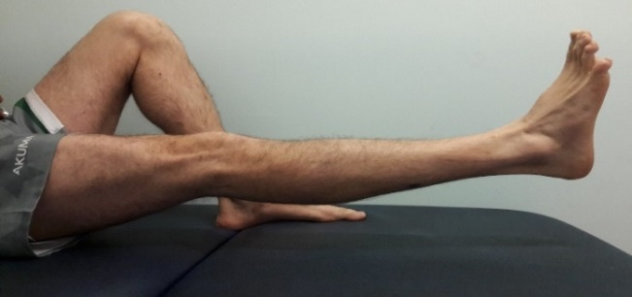
Exercises (continued)

- Knee slides
In lying, bend your knee as far as you can, hold for 5 seconds, then straighten. Repeat 10 times.
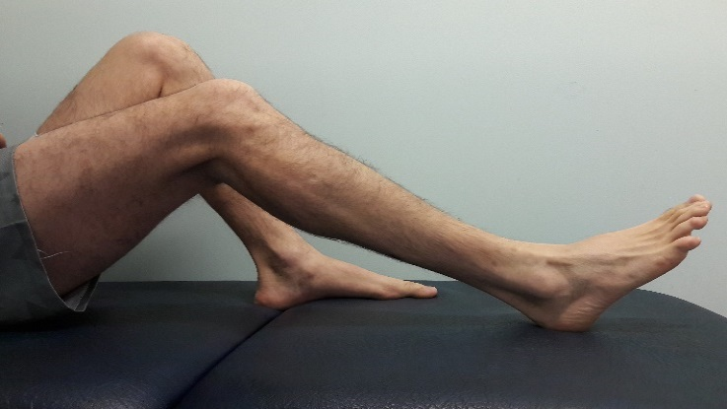

- Sit to stand
Sit to stand slowly 10 times. Try to avoid using your arms to help.

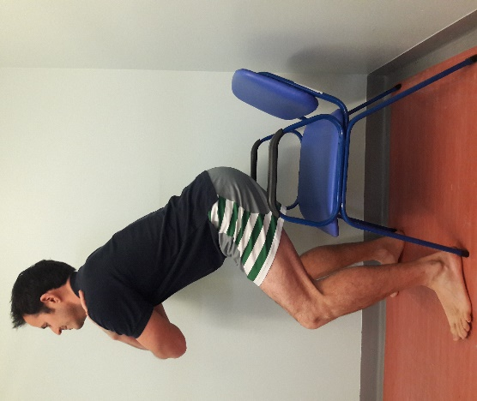
- Bridging
Lie on your back with your knees bent, try and lift your hips up a short distance. Hold 5 seconds. Repeat 5-10 times.

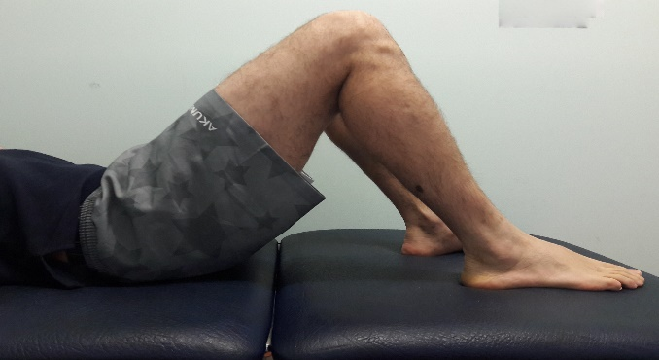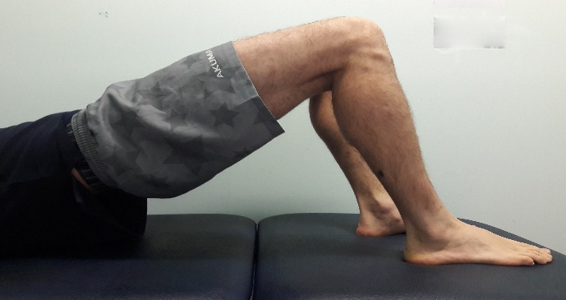

Further information

We would recommend attending one of our physiotherapy classes to get the best information and advice. However if you are unable to get to a physiotherapy department you can access education and exercise videos online at: www.escape-pain.org or via the Escape Pain app available free from the app store.

You can find contact details for the physiotherapy service on our website https://wiltshirehealthandcare.nhs.uk/physiotherapy/

Useful resources

Versus Arthritis (previously Arthritis Research UK);
- Knee Osteoarthritis
https://www.versusarthritis.org/about-arthritis/conditions/osteoarthritis-of-the-knee/

- Hip Osteoarthritis
https://www.versusarthritis.org/about-arthritis/conditions/osteoarthritis-oa-of-the-hip/

- NICE guidelines on OA
https://www.nice.org.uk/guidance/cg177

- NHS Osteoarthritis information
www.nhs.uk/conditions/osteoarthritis

- Pain medication advice
http://www.nhs.uk/Livewell/Pain/Pages/Whichpainkiller.aspx

- Managing weight/healthy diet
https://www.nhs.uk/change4life/
https://www.nhs.uk/live-well/healthy-weight/
https://www.nhs.uk/conditions/obesity/

- Relaxation
http://www.learnrelaxationtechniques.com/1221/free-guided-meditation-resources/

Safeguarding
Wiltshire Health and Care has a strong commitment to care that is safe, of a high quality and that upholds our patients’ rights. All our patients have the right to live lives free from abuse or neglect and, where they are able, to make or be supported to make informed decisions and choices about their treatment, care and support. Where patients are not able to make their own decisions, Wiltshire Health and Care staff are committed to ensuring that treatment, care and support is undertaken in accordance with the person’s best interests. In order to fulfil these commitments, Wiltshire Health and Care follow the Safeguarding principles and responsibilities laid out in Sections 42-46 of the Care Act (2014) and are informed by, and apply, the guiding principles and provisions of the Mental Capacity Act (2005).
If you or your carer have any concerns about abuse, neglect or your rights in relation to care provided by Wiltshire Health and Care or any other agency or individual, please raise this directly with any Wiltshire Health and Care staff or contact the Safeguarding Adults Team by telephone on: 0300 456 0111.

Wiltshire Health and Care Patient Advice and Liaison Service (PALS)

If you have any questions, or concerns, suggestions or compliments about our service, please speak to a member of staff.

This information sheet is available in other languages and formats. If you would like a copy, please contact us on 0300 123 7797 and whc.pals@nhs.net

