Anatomy

The hip joint is a ball-and-socket joint where the ball (the femoral head) moves within the socket (the acetabulum).
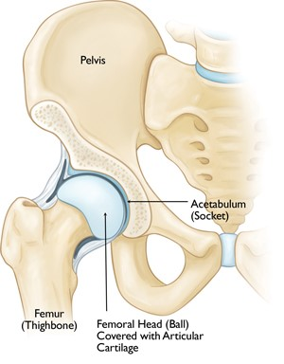
What is Femoroacetabular impingement syndrome (FAI)?

FAI is a condition where there are changes to the normal contact between the femoral head and the acetabulum caused by changes to the bones (explained on the next page). This can result in painful irritation of the hip joint.
FAI will typically affect people under the age of 45 and can be more common in active people who complete repetitive forwards hip movements. Symptoms of FAI can also present in slightly older people. However. this is usually associated with early osteoarthritis of the hip and may be managed slightly differently.

What causes FAI?

Bony changes of the hip joint are common in people with or without pain. However, they can be a contributing factor to hip pain. FAI may occur when the presence of these bony changes are combined with completing repetitive forward hip movements/positions, either quickly or under load-i.e. with additional weight.
The bony changes that cause FAI can be present from birth or can happen in adolescence when our bones are developing.

There are three types of FAI:

- Pincer. This is where the hip socket (acetabulum) covers more of the femoral head than normal.
- Cam. This describes a slight alteration in the shape of your femoral head.
- Combined. This is when both Cam and Pincer deformities occur together, and is the most common presentation.

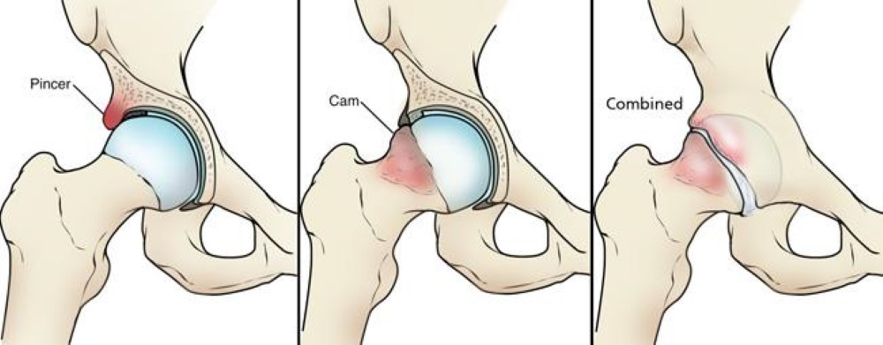

What are the common symptoms?

- Pain in the groin, usually related to certain movements and/or positions
- Pain may also be reported in the side of the hip or buttock area
- Stiffness or reduced movement in the hip- most commonly in the movement of flexion where the thigh travels forward (knee towards chest)
- Clicking, catching or giving way may suggest an issue with the labrum of your hip. The labrum is a cartilaginous ring around the acetabulum, and FAI can predispose you to small tears in this structure.
What can you do to help yourself?

Be positive and keep moving!

Activity modification

If you have recently increased or changed your activity levels or training programme, then reducing this slightly may help. You can do this by reducing the duration/intensity of exercise and/or allowing slightly longer recovery periods in between. If an activity causes severe pain then you may need to rest or modify the activity until your pain has reduced.

If returning from reduced activity levels or a period of rest, ensure you gradually increase your return to activity.

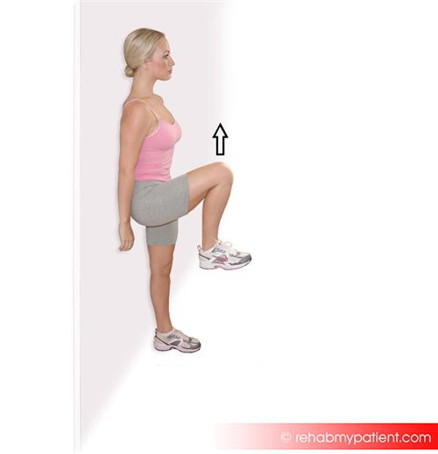
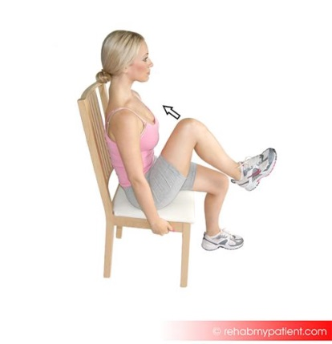
It can be helpful to reduce repetitive movements of extreme hip flexion if these cause pain in your hip. These may include;
Hip flexion movement

- walking uphill
- running or sprinting
- cycling
- Rowing
- deep squatting
- kicking
- prolonged sitting in a low chair
While you should work to maintain mobility of your hip, try to avoid repeated stretching into the painful movements.

Pain relief

You may be prescribed simple pain relief or anti-inflammatory medication: take this as prescribed until the pain settles. Your GP or Pharmacist will advise you on this.

Heat or cold

Heat or cold therapy can be used to help pain. Use an ice pack wrapped in its cover or a damp tea towel for up to 15 minutes. Alternatively try using a wheat bag/hot water bottle wrapped in a towel/cover. Make sure to protect your skin with a towel and regularly check your skin to avoid any skin damage, as both can cause burns if used incorrectly.

Exercise

Exercise is a very helpful method of improving movement, strength and function. General cardiovascular exercise can be beneficial when completed regularly i.e. walking, jogging and cycling. In addition to this, mobilising and strengthening exercises are both effective in the treatment of FAI. You should try to complete the exercise programme on approximately 5 days each week. Have at least 1-2 rest days per week.

The first section has beginner exercises to get you started. Your Physiotherapist may choose to progress or modify these. When completing these exercises, you may experience mild discomfort. This is OK if this discomfort settles quickly i.e. within 10-15 minutes. If you find an exercise causes persistent pain for the rest of the day OR severe pain, please stop the exercise involved and speak to your physiotherapist or GP.

The repetitions and sets given are a guide figure which you may adjust to suit your symptoms and/or ability. As a general rule, try to repeat each exercise until your muscles begin to feel tired.

If you do not find the beginner exercises challenging, and if you experience no pain from completing them, you may consider progressing to the intermediate exercises.

If your symptoms do not settle and you are referred to a physiotherapist, they may design an exercise programme more specifically tailored to your needs.

Beginner exercises
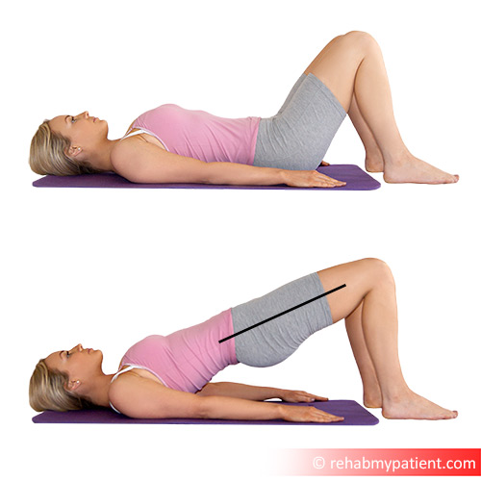 | Beginner glutes  Adopt the supine start position shown.  Tilt your pelvis back underneath you, pressing your lower back into the floor. Squeeze your buttock muscles (glutes) to push your bottom into the air.  Hold this position for 3-5 seconds then slowly lower.  Repeat for 8-12 repetitions (one set).  Complete 3-4 sets of this exercise.  Make sure you keep your weight equal through both feet. Repeat as required.  May be completed on the floor or on a bed.  https://youtu.be/R1qxWNjcleU
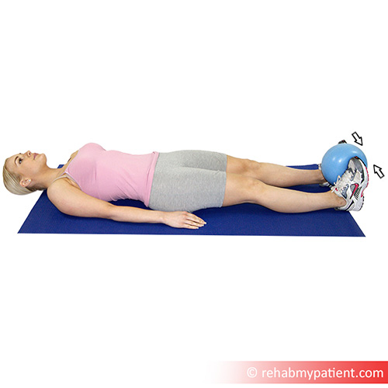 | Beginner adductors  Lie down, and place a ball or cushion between your feet so that your feet are about hip-width apart. Squeeze the ball/cushion with both legs as hard as you can and hold for 3-5 secs. Relax slowly.  Repeat for 8-12 repetitions (one set).  Complete 3-4 sets of this exercise.  This exercise is a strengthening exercise for the adductor muscle group.  May be completed on the floor or on a bed.  https://youtu.be/vsXjFlVpW9Q
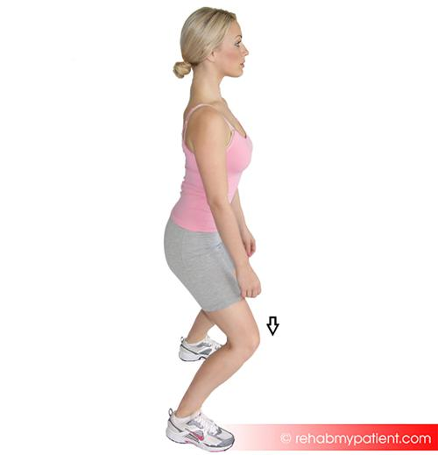 | Beginner quads  Open your legs slightly wider than shoulder width, and slowly bend your knees to the 1/2 squat position as shown.  Hold this position for 3-5 seconds before pushing through your legs to return to standing.  Repeat for 8-12 repetitions (one set).  Complete 3-4 sets of this exercise.  Make sure you keep the middle of your knee-cap in line with the middle toes of your foot.  https://youtu.be/b1JD-Bzw7kQ
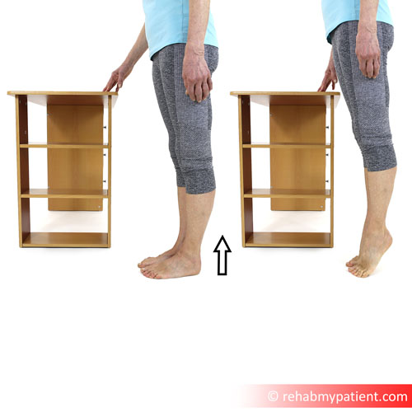 | Beginner calves  Stand upright with good posture. Hold on to a wall, rail or table for support. Slowly raise up onto your toes, hold for 3-5 seconds and control the movement back down.  Repeat for 8-12 repetitions (one set).  Complete 3-4 sets of this exercise.  This exercise will strengthen the calf muscles and ankle joints.  https://youtu.be/6cqQXAaZ8CU

Intermediate exercises
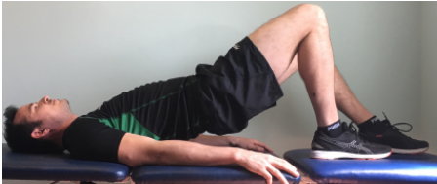 | Intermediate glutes  Lie on a firm surface. Place one foot closer to your bottom and one a little further away. You can alter this as needed / comfortable. Lift your bottom off the floor by pushing through your feet, activating your gluteal, core and hamstring muscles, hold 5 seconds and then lower.  Try to keep your pelvis level as you do this.  The leg closer to your bottom should be the leg you are trying to strengthen.  Repeat for 8-12 repetitions (one set).  Complete 3-4 sets of this exercise.  https://www.youtube.com/watch?v=e1XAfYIlqk0
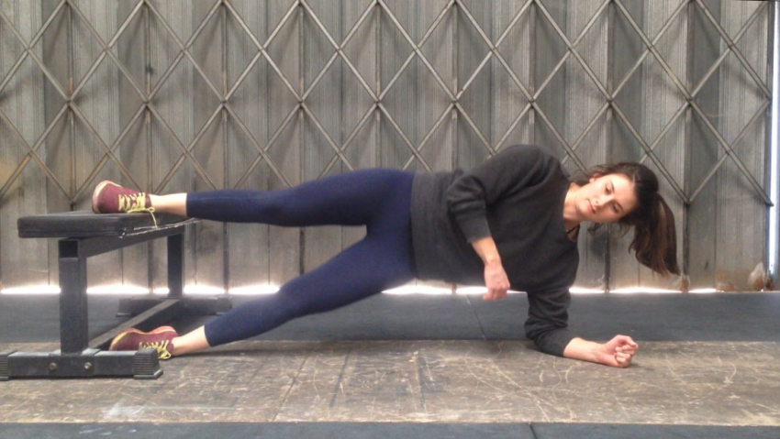 | Intermediate adductors  Note: Do not complete this exercise (unless specifically advised by your Physiotherapist) if you have any other musculoskeletal conditions or complaints.  Lie on your side with your top foot on a bench (or sturdy chair). Leave the other foot on the floor underneath. The idea is to exercise the inner thigh muscles of the top leg - the bottom leg is there to assist the movement.  Slowly control the movement of the hips up (as shown) and down whilst maintaining a straight line with your body.  Repeat for 8-12 repetitions (one set).  Complete 3-4 sets of this exercise.  https://youtu.be/ivm5GF2SuXs
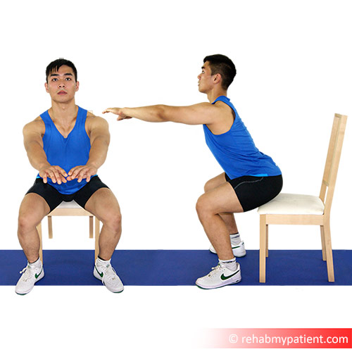 | Intermediate quads  Stand up, and position yourself in front of a chair or stool. Bend your knees slowly to go into a squat position, and gently touch your bottom on the chair. Hold for 3-5 seconds.  Then, push up into standing.  Throughout the exercise, keep your knee in-line with your foot and do not let your knee drift outwards or inwards. Also keep your hips and pelvis level as you squat, so you go down in a straight line.  Repeat for 8-12 repetitions (one set).  Complete 3-4 sets of this exercise.  Note: if this irritates your hip, you can try performing the squat from a higher surface to reduce the strain.  https://youtu.be/Z20XNb0VdEk
Further management

If your symptoms persist despite 6-12 months of physiotherapy and rehabilitation exercises, your health care professional may refer you into an orthopaedic pathway for consideration of other interventions. The decision to refer you will be dependent on your pain levels and ability to carry out normal activities. In some cases, a referral may be considered after 3 months but this will be dependent on your pain levels and ability to carry out normal activities.

Further interventions may include:
- Corticosteroid injection
- Arthroscopic (keyhole) surgery
- Open hip surgery

There are risks associated with each of these procedures. They are only indicated if pain is severe and/or substantially interfering with day-to-day function. Each intervention should be a risk-versus-benefit decision made in collaboration with a suitable health care professional.

Further Information

If you would like to seek the advice of a Physiotherapist, there are a number of options within Wiltshire. Please speak to your GP practice about the ways you can be referred.
Alternatively visit our website;
https://wiltshirehealthandcare.nhs.uk/physiotherapy/

Other useful websites:
https://www.activewiltshire.org.uk/
Here you will find information on improving your activity level and details of what is available in your local area.

http://www.wiltshire.gov.uk/public-health-weight
Here you will find information about weight management options in your local area.

http://www.wiltshire.gov.uk/public-health-trainers
Health Trainers work on a one to one basis to support behaviour change and aiming to improve health. They concentrate on behaviours associated with ill health including unhealthy eating often linked to obesity, stopping or reducing smoking, sensible drinking, increasing physical activity, building confidence and motivation to change, and boosting self-esteem. They also signpost and support clients to access other services and activities where appropriate.

Safeguarding
Wiltshire Health and Care has a strong commitment to care that is safe, of a high quality and that upholds our patients’ rights. All our patients have the right to live lives free from abuse or neglect and, where they are able, to make or be supported to make informed decisions and choices about their treatment, care and support. Where patients are not able to make their own decisions, Wiltshire Health and Care staff are committed to ensuring that treatment, care and support is undertaken in accordance with the person’s best interests. In order to fulfil these commitments, Wiltshire Health and Care follow the Safeguarding principles and responsibilities laid out in Sections 42-46 of the Care Act (2014) and are informed by, and apply, the guiding principles and provisions of the Mental Capacity Act (2005).
If you or your carer have any concerns about abuse, neglect or your rights in relation to care provided by Wiltshire Health and Care or any other agency or individual, please raise this directly with any Wiltshire Health and Care staff or contact the Safeguarding Adults Team by telephone on: 0300 4560111.
Regarding children, WHC is responsible for providing services in accordance with Section 11 of the Children’s Act (1989) and works under the principles of Working Together to Safeguard Children (2018).

Patient Advice and Liaison Service (PALS)

If you have any questions, or concerns, suggestions or compliments about our service, please speak to a member of staff.

This information sheet is available in other languages and formats. If you would like a copy, please contact us on 0300 1237797 and PALS.wiltshirehealthandcare@nhs.net

Patient and Public Involvement
We value your opinions which will help us to further develop our services.
If you wish to provide feedback or get involved in our patient participation groups, please email the Patient and Public Involvement Officer at ask.wiltshirehealthandcare@nhs.net or telephone 01249 454386.

