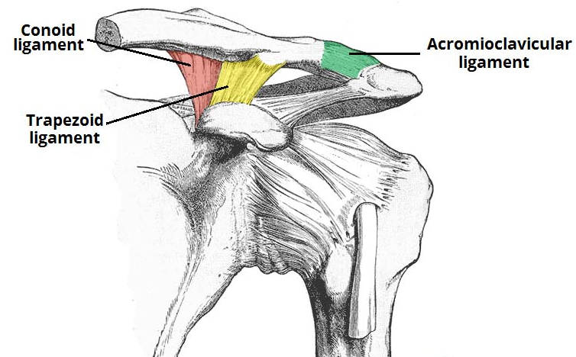

The Acromioclavicular Joint (ACJ) is the joint between the acromion process (top of the shoulder blade) and the clavicle (collar bone). The joint is supported by three strong bands of ligament (pictured in colour) which help to keep it stable. A healthy ACJ allows full movement of the shoulder and normal function of the arm. The ligaments supporting the joint can be injured and this can lead to pain and reduced movement of the arm. Usually overhead movements are most affected.

Causes of ACJ injury
- It is more common in sports following heavy contact e.g. a rugby tackle or a fall onto the point of the shoulder.
- It is most common in a younger age group
- Men are five times more likely than women to injure the joint.
Have I injured my ACJ?
The following signs might indicate an ACJ injury:
- Pain local to the top of the shoulder at the end of the collar bone (ACJ)
- You have fallen onto the shoulder usually with the arm tucked under the body
- Difficulty and pain lifting the arm above shoulder height, across the body or behind the back
- The bony bump at the end of the collar bone is more prominent than the other side.
What should I do?
If you have fallen and have pain or difficulty lifting your arm, then you should seek medical attention because you may require an x-ray of the shoulder. You will then be informed whether you might need an operation. If you do not, then the following will help:
- 1-2 weeks of rest using a sling
- Early gentle exercise to avoid stiffness (see exercises later in this leaflet)
- Use ice over the area for up to 10 minutes, applying a damp cloth first to avoid ice burns
- Pain killers/Non-steroidal anti-inflammatories (discuss with your GP or pharmacist)
- Referral to a Physiotherapist (self-referral or via the GP)
- Avoid heavy lifting or sports until the pain has settled
How long will it take to get better?
Following an ACJ injury, recovery time depends on the level of injury to the supporting ligaments. These levels are graded from 1-6;
Levels 1-3 are the most common (ligament sprain or tear with very little displacement of the bone); these are usually managed without an operation.
Levels 4-6 involve complete ligament tears and may lead to significant instability of the joint, often requiring an operation.

Small sprains of the ACJ can take up to 3 months to get better. Larger injuries can take longer, usually up to 6 months. If you require surgery, then the recovery period can be up to 12 months. Following an injury some people are left with a prominent bony bump in the area.

Warning signs
Occasionally injuries to the ACJ may lead to other problems or the pain may represent something different. You should seek urgent medical attention if you notice:
- Persistent tingling or numbness into the same arm/hand
- Change in colour or temperature to the arm/hand
- Progressively worsening pain
- Unable to lift the arm at all
- Difficulty breathing or chest pain
Exercises:
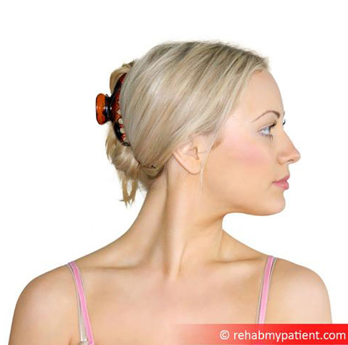
Neck movement

Ensure that you keep your neck moving regularly as it is prone to getting stiff with ACJ injuries. Turn and bend the neck from side to side regularly throughout the day.
If you ever feel dizzy when turning your head then discontinue the exercise and discuss this with your GP

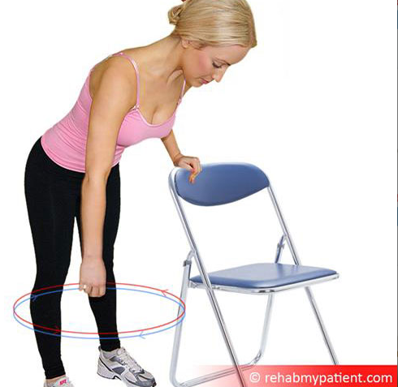
Pendulum shoulder movement

Lean forward and gently allow the arm to drift forward. Keep the shoulder blades up to stop the weight of arm dragging on the shoulder. Now slowly move the arm in small circular movements.
Do 5-10 circles clockwise and 5-10 circles anti-clockwise.
Repeat this 2-3 times a day

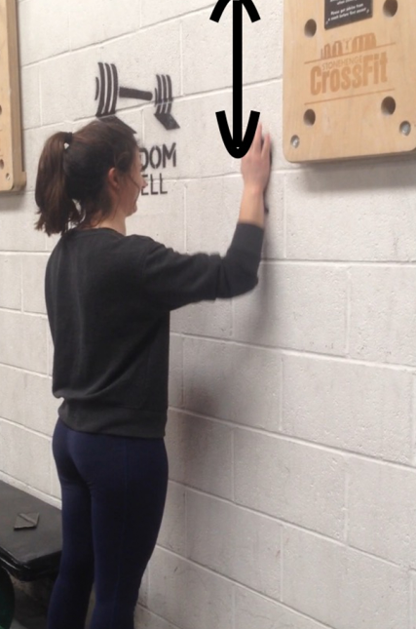
Wall slide

Place the hand on a wall, using a piece of fabric between the hand and wall will help with movement. Slowly slide the hand up the wall so that the shoulder elevates. Stop the when the arm reaches shoulder height (as demonstrated), hold for 5 seconds and then lower back down.
Repeat this 5-10 times
Repeat this 2-3 times a day
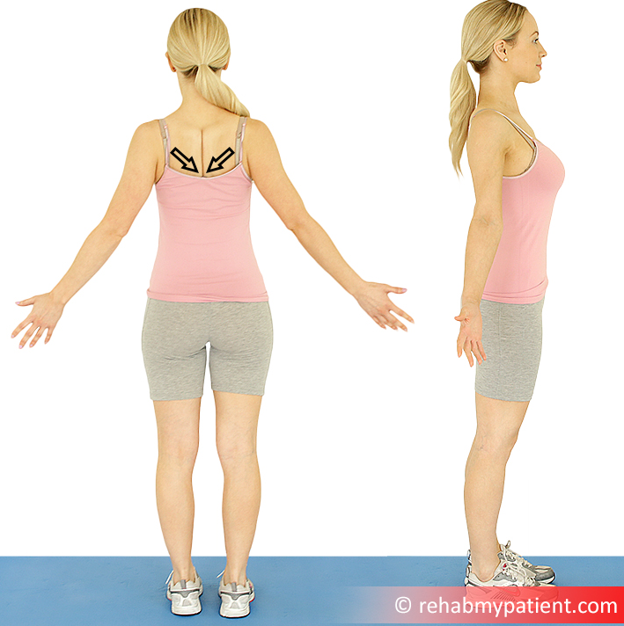
Shoulder openers

Turn your palms forwards and gently open the chest. Do not stretch the arms behind the body, this will pull on the ACJ. Take deep breaths as your open the arms.

Repeat regularly throughout the day
Further Information
If you would like to seek the advice of a Physiotherapist, there are a number of options within Wiltshire. Please speak to your GP practice about the ways you can be referred. Alternatively visit our website;
https://wiltshirehealthandcare.nhs.uk/physiotherapy/
Other useful websites:

https://www.activewiltshire.org.uk/
Here you will find information on improving your activity level and details of what is available in your local area.
http://www.wiltshire.gov.uk/public-health-weight
Here you will find information about weight management options in your local area. http://www.wiltshire.gov.uk/public-health-trainers
Health Trainers work on a one to one basis to support behaviour change and aiming to improve health. They concentrate on behaviours associated with ill health including unhealthy eating often linked to obesity, stopping or reducing smoking, sensible drinking, increasing physical activity, building confidence and motivation to change, and boosting self-esteem. They also signpost and support clients to access other services and activities where appropriate.

Safeguarding
Wiltshire Health and Care has a strong commitment to care that is safe, of a high quality and that upholds our patients’ rights. All our patients have the right to live lives free from abuse or neglect and, where they are able, to make or be supported to make informed decisions and choices about their treatment, care and support. Where patients are not able to make their own decisions, Wiltshire Health and Care staff are committed to ensuring that treatment, care and support is undertaken in accordance with the person’s best interests. In order to fulfil these commitments, Wiltshire Health and Care follow the Safeguarding principles and responsibilities laid out in Sections 42-46 of the Care Act (2014) and are informed by, and apply, the guiding principles and provisions of the Mental Capacity Act (2005).
If you or your carer have any concerns about abuse, neglect or your rights in relation to care provided by Wiltshire Health and Care or any other agency or individual, please raise this directly with any Wiltshire Health and Care staff or contact the Safeguarding Adults Team by telephone on: 0300 4560111.
Regarding children, WHC is responsible for providing services in accordance with Section 11 of the Children’s Act (1989) and works under the principles of Working Together to Safeguard Children (2018).

Patient Advice and Liaison Service (PALS)

If you have any questions, or concerns, suggestions or compliments about our service, please speak to a member of staff.

This information sheet is available in other languages and formats. If you would like a copy, please contact us on 0300 1237797 and PALS.wiltshirehealthandcare@nhs.net

Patient and Public Involvement
We value your opinions which will help us to further develop our services.
If you wish to provide feedback or get involved in our patient participation groups, please email the Patient and Public Involvement Officer at ask.wiltshirehealthandcare@nhs.net or telephone 01249 454386.

