**Wiltshire Health and Care**

**Easy Read Delivery Plan**

Our plan for the next 3 years:

|  |  |
| --- | --- |
| We will look at keeping you well and how we can do it better. |  |
| If you are ill, we will visit you at anytime, day or night. | Night |
| We will make your time in hospital better. |  |
| We will help you get home from hospital quickly. |  |
| If you live in a care home, we will work better to keep you well. |  |
| We will keep you safe from Covid-19.  We will wear gloves, masks, aprons and visors. |  |
| And sometimes you will need to wear a mask. |  |
| We can still use computers to talk to you.  We will also visit you again. |  |
| We will make sure you have a yearly health check. |  |
| Make sure you have a care and support plan. | **Care and support plan** |
| We will keep our staff trained. |  |
| We will support more volunteers to help us. |  |
| We will work hard to keep staff happy in their jobs. |  |
| We will keep your information safe. |  |
| We will make it easier for you to speak to us on the phone. |  |
| We will give everyone an equal service.  Everyone will be treated the same. |  |
| You can help us to do better, by giving us feedback. |  |
| We will always try to provide the best service, whilst saving money. |  |
| We will use less plastic. | recycle |

If you would like to tell us more about how we can make services better for you,

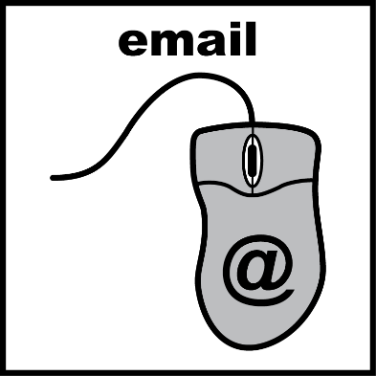Email us at:

[pals.wiltshirehealthandcare@nhs.net](mailto:pals.wiltshirehealthandcare@nhs.net)



Or Telephone: 0300 123 7797